**ADS Assignment**

Problem 1:

Given an array of integers, perform the following operations:

1. Find the second largest element in the array.

2. Move all zeros to the end of the array while maintaining the order of non-zero elements.

Input:

arr = [10, 0, 5, 20, 0, 8, 15]

Output:

Second largest element: 15

Array after moving zeros: [10, 5, 20, 8, 15, 0, 0]

Constraints:

● Do not use built-in sort functions.

● The array may contain duplicate elements or zeros at any position.

● Array length ≥ 2.

Ans :

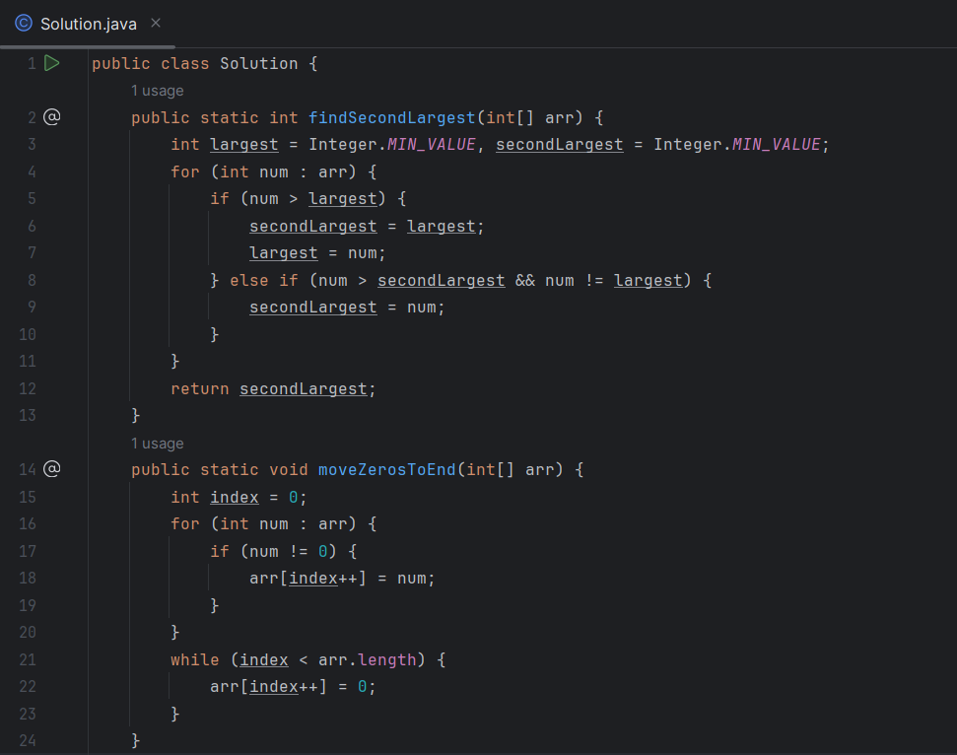

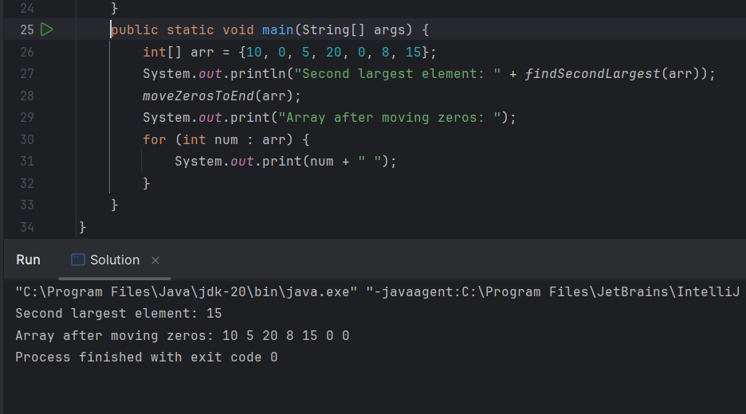

Problem 2:

Write a program that performs the following operations on strings:

1. Check whether two given strings are anagrams of each other.

2. Identify the longest word in a given sentence.

3. Count the number of vowels and consonants in the same sentence.

Input:

String 1: listen

String 2: silent

Sentence: Practice makes a man perfect

Output: Are 'listen' and 'silent' anagrams? True

Longest word: Practice

Vowels: 9, Consonants: 17

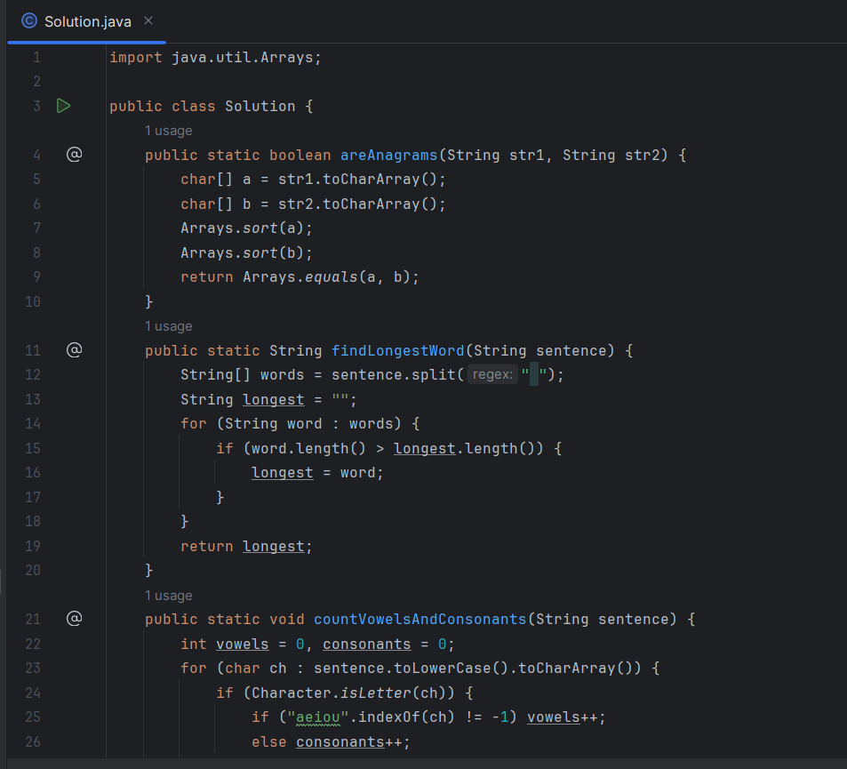

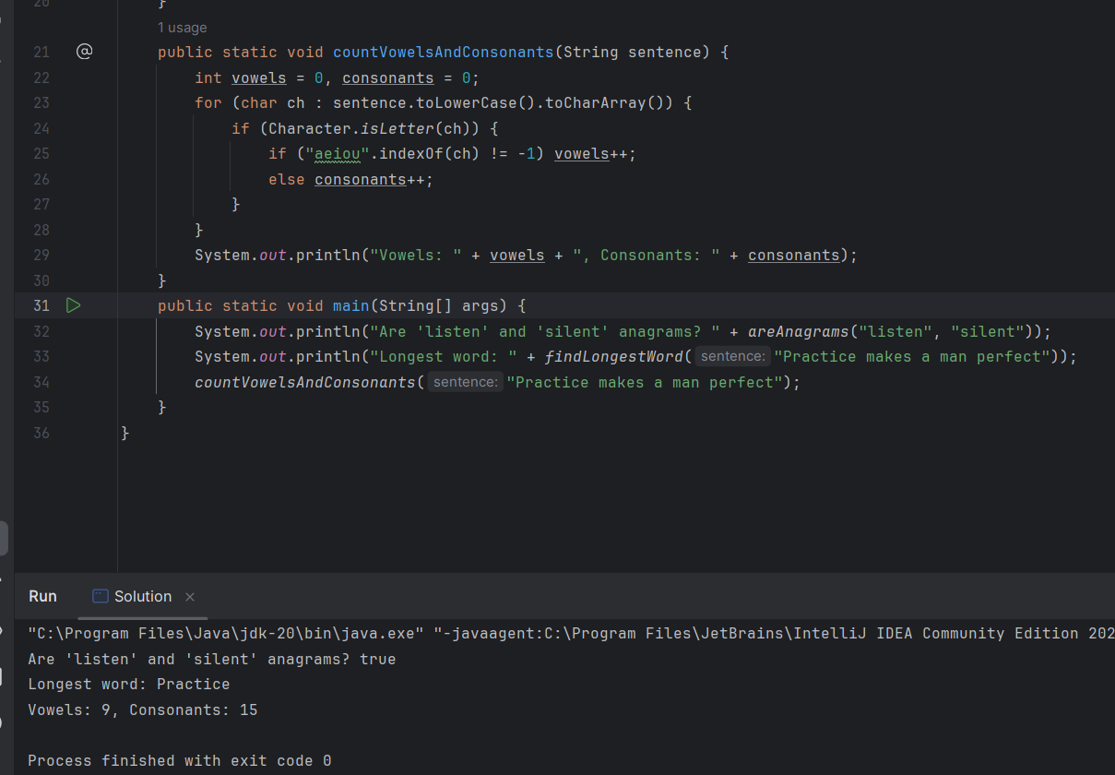

Problem 3:

Given a sorted array of integers (which may include duplicates), perform the following operations:

1. Search for a given key and return its index (if found) with Binary Search.

2. Find the first and last occurrence of the key in the array.

3. Count the total number of times the key appears.

4. Find any peak element in the array (an element greater than its neighbors).

Input:

arr = [1, 3, 3, 3, 5, 6, 8], key = 3

Input for Peak Element:

arr =[1, 2, 18, 4, 5, 0]

Output:

Key found at index: 2

First occurrence: 1

Last occurrence: 3

Total count of key: 3

Peak element: 18

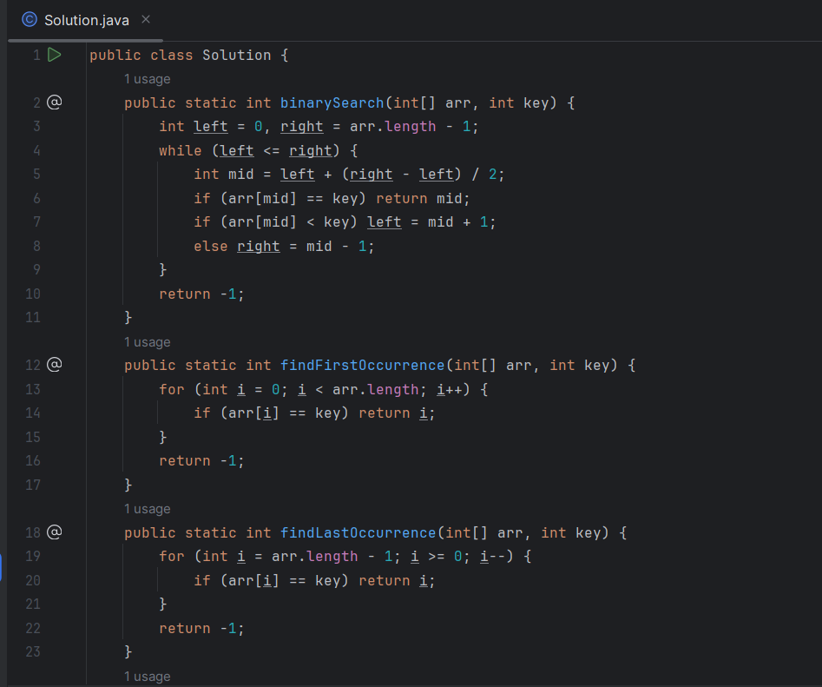

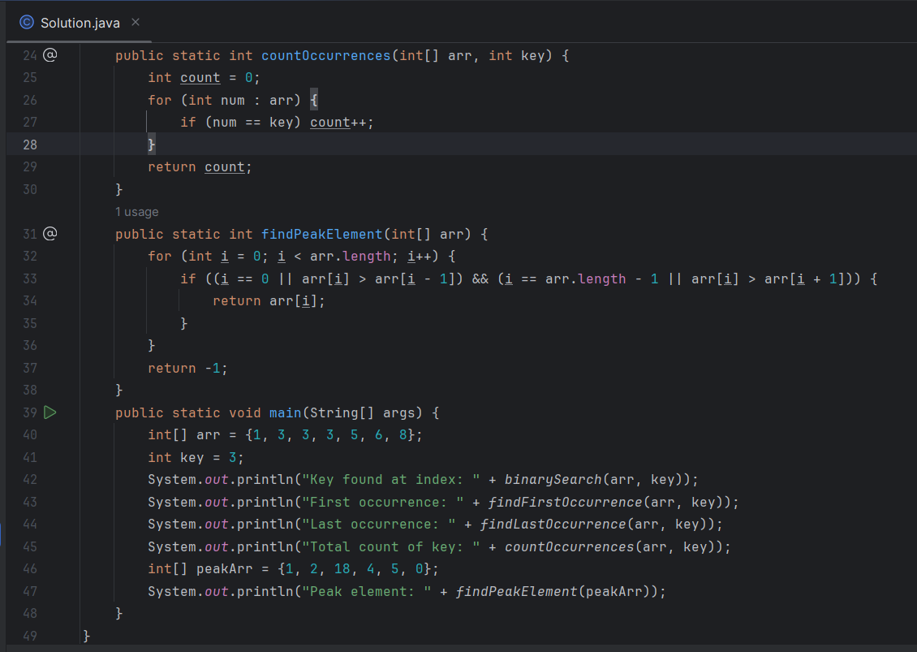

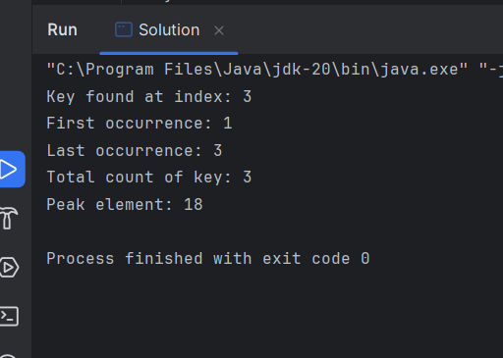

Problem 4:

Write a recursive program that performs the following operations:

1. Check if a number is prime using recursion.

2. Check whether a given string is a palindrome.

3. Find the sum of digits of a given number.

4. Calculate the nth Fibonacci number.

5. Calculate a raised to the power b

Input:

num = 7

str = "racecar"

num = 1234

fibIndex = 6

a = 2, b = 5

Output:

Is prime: true

Is 'racecar' a palindrome? True

Sum of digits of 1234: 10

Fibonacci(6): 8

2^5 = 32

Constraints:

● Do not use loops or built-in reverse methods.

● Use charAt() for string access.

● You can assume valid positive integer inputs.

Ans :

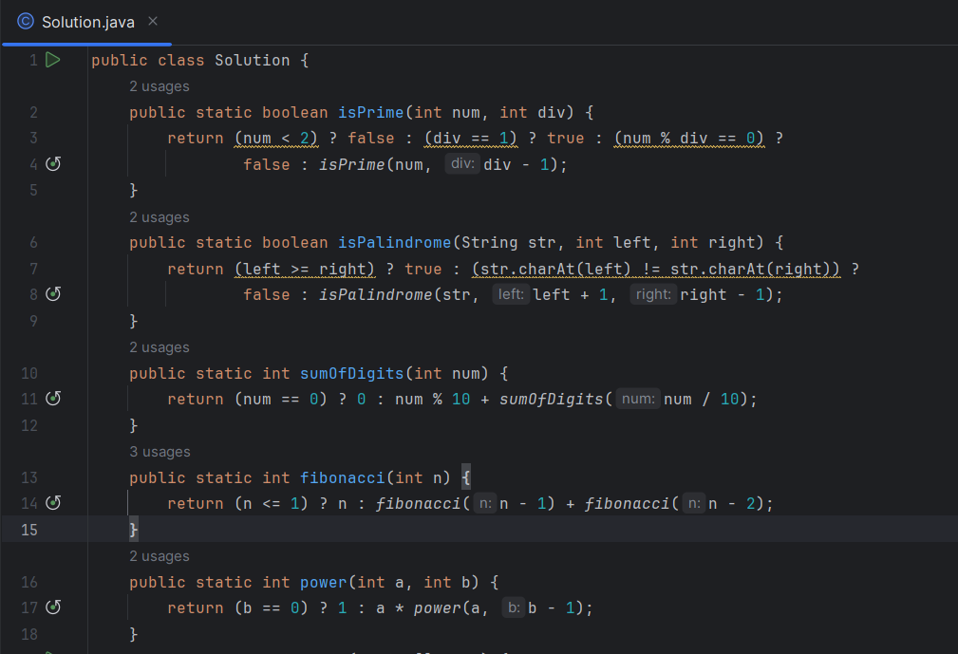

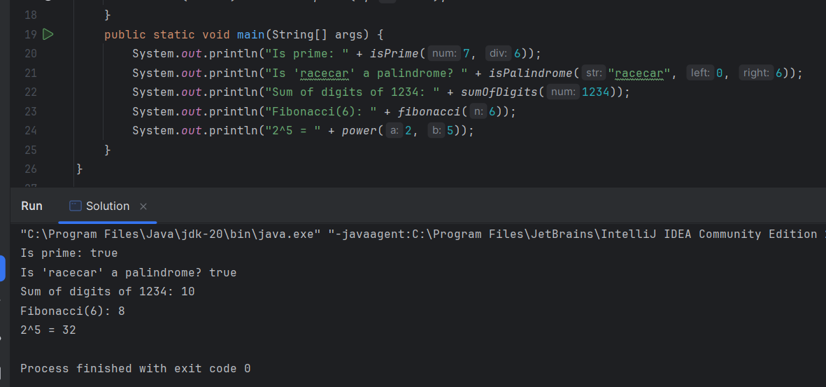

Problem 5:

Dry Run & Analyze: Time and Space Complexity

1. Dry run the code for n = 4. How many times is * printed? What is the time complexity?

void printTriangle(int n) {

for (int i = 0; i < n; i++)

for (int j = 0; j <= i; j++)

System.out.print("*");

}

2. Dry run for n = 8. What’s the number of iterations? Time complexity?

void printPattern(int n) {

for (int i = 1; i <= n; i *= 2)

for (int j = 0; j < n; j++) S

ystem.out.println(i + "," + j);

}

3. Dry run for n = 20. How many recursive calls? What values are printed?

void recHalf(int n) {

if (n <= 0) return;

System.out.print(n + " ");

recHalf(n / 2);

}

4. Dry run for n = 3. How many total calls are made? What’s the time complexity?

void fun(int n) {

if (n == 0) return;

fun(n - 1);

fun(n - 1);

}

5. Dry run for n = 3. How many total iterations? Time complexity?

void tripleNested(int n) {

for (int i = 0; i < n; i++)

for (int j = 0; j < n; j++)

for (int k = 0; k < n; k++)

System.out.println(i + j + k);

}

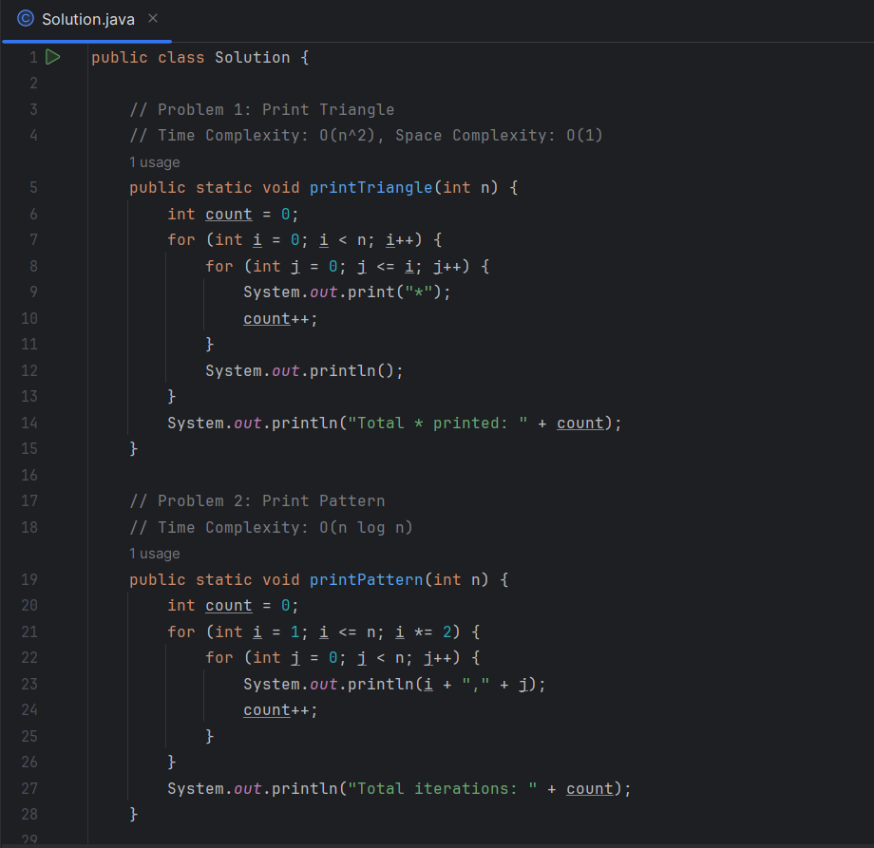

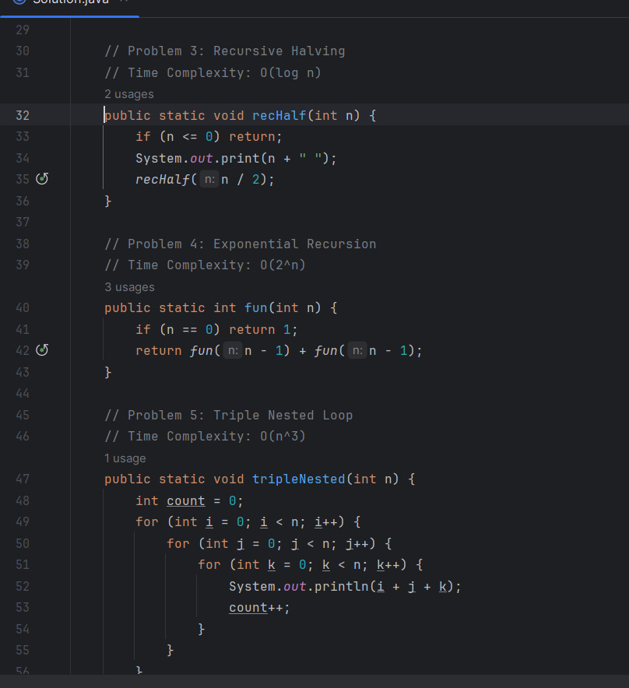

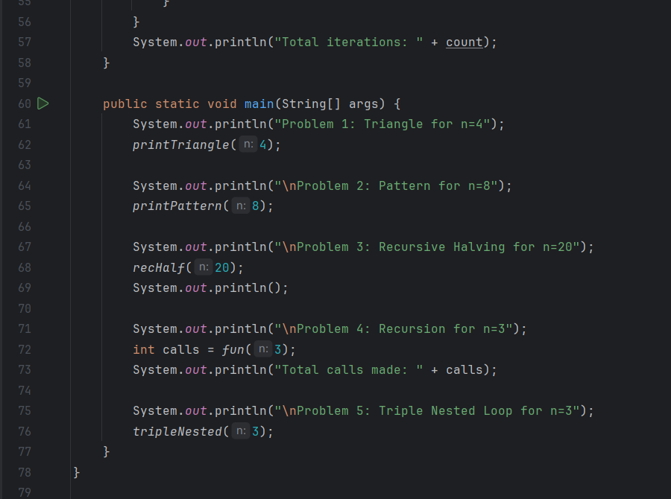

"C:\Program Files\Java\jdk-20\bin\java.exe" "-javaagent:C:\Program Files\JetBrains\IntelliJ IDEA Community Edition 2023.2\lib\idea_rt.jar=40033:C:\Program Files\JetBrains\IntelliJ IDEA Community Edition 2023.2\bin" -Dfile.encoding=UTF-8 -Dsun.stdout.encoding=UTF-8 -Dsun.stderr.encoding=UTF-8 -classpath C:\Users\LEN0V0\IdeaProjects\String\out\production\String Solution

Problem 1: Triangle for n=4

*

**

***

****

Total * printed: 10

Problem 2: Pattern for n=8

1,0

1,1

1,2

1,3

1,4

1,5

1,6

1,7

2,0

2,1

2,2

2,3

2,4

2,5

2,6

2,7

4,0

4,1

4,2

4,3

4,4

4,5

4,6

4,7

8,0

8,1

8,2

8,3

8,4

8,5

8,6

8,7

Total iterations: 32

Problem 3: Recursive Halving for n=20

20 10 5 2 1

Problem 4: Recursion for n=3

Total calls made: 8

Problem 5: Triple Nested Loop for n=3

0

1

2

1

2

3

2

3

4

1

2

3

2

3

4

3

4

5

2

3

4

3

4

5

4

5

6

Total iterations: 27

Process finished with exit code 0